For Immediate Release  Press Contact:  Emily Anne Evans  Marketing & Communications Manager  310.396.0317 x217  eaevans@awbw.org  Tickets: awbw.org/aia  @AWBWorg • #ArtInTheAfternoon | 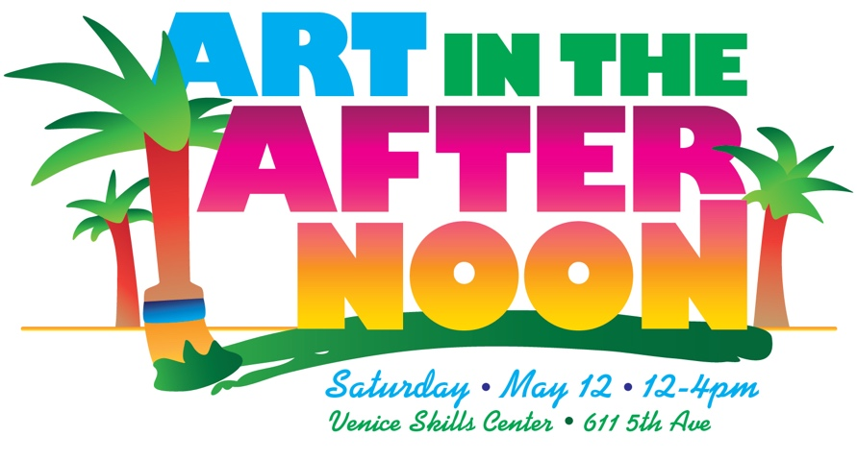

Fun-filled Art Festival for the Whole Family
Art in the Afternoon, hosted by G Hannelius, celebrates the healing power of art

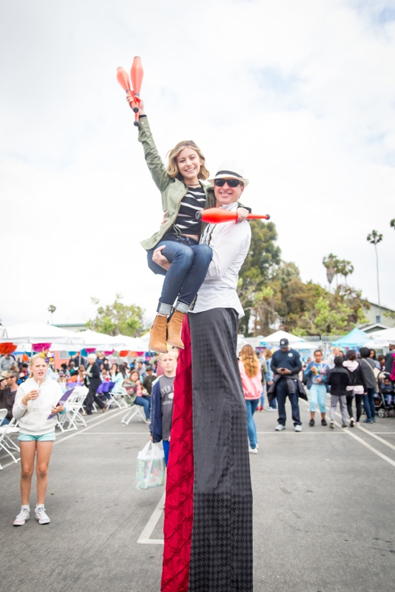  G Hannelius with circus performer Rob Crites.  Photo by Leetal Photo  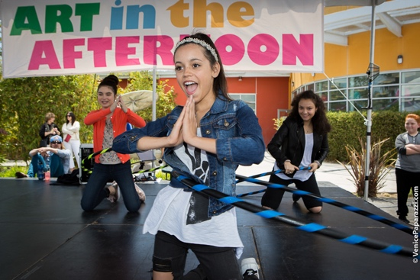  Jenna Ortega Hooping it Up. Photo by Venice Paparazzi  These photos and more available at awbw.org/media | Venice, CA – April 16, 2018 - On Saturday, May 12, 12-4pm nonprofit A Window Between Worlds (AWBW) will host Art in the Afternoon, their popular annual art festival, at the Venice Skills Center, 611 5th Avenue. Hosted by G Hannelius of “American Vandal”, this unique festival brings out 700 people from across Los Angeles and Southern California for a day of art projects, carnival games, teen celebrity meet-and-greets, food and entertainment.  Tickets are available at awbw.org/aia. Kids (12 and under) are $15, Teens (13-17) $25 and Adults $60 — all in support of AWBW’s healing art workshops for survivors of trauma and violence.  This year Syncopated Ladies will perform, along with Hoop It Up Kids and more live entertainment. A Despicable Me Minion will be roaming the festival and stars from Disney’s “Bunk’d”, “Walk the Prank” and “Dog with a Blog” will be in attendance.  Admission includes a variety of AWBW art activities — special guest artist Fabian Debora will be leading the mural area — plus free food from In-N-Out® Burger (12-2pm), Panda Express, Greenleaf Gourmet Chopshop and more. Jeni’s Splendid Ice Creams truck will also be there, along with ticketed art projects such as Color Me Mine and DIY flower crowns. Kids can enjoy games and other activities while their parents get a massage in the wellness zone or check out the silent auction.  AWBW collaborates with over 200 shelters, outreach centers, schools and other human service programs throughout the country to provide art as a tool for healing and empowerment through hands-on workshops.  Proceeds for Art in the Afternoon directly benefit AWBW’s network of partners through funding scholarships, art supplies, trainings, curriculum development and the launching of new partnerships.  Additional community supporters of Art in the Afternoon include Universal Studios Hollywood, Google LA, Hogan Lovells, The Art Institute of CA – Hollywood and Blick Art Materials. ###

