FOR IMMEDIATE RELEASE  Press Contact:  Emily Anne Evans  A Window Between Worlds  Marketing and Communications Manager  310.396.0317 x217 • eaevans@awbw.org  awbw.org/heartawards  @AWBWorg | Thirty-six panel painting by Mike Chearney, titled A Window Between Worlds, to be auctioned as individual pieces at nonprofit A Window Between Worlds’ heART Awards October 1.
Brunch Celebrates Creativity, Compassion and Community

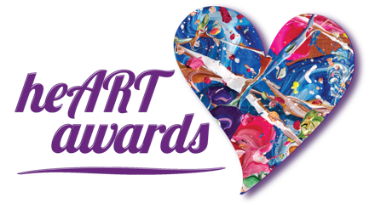  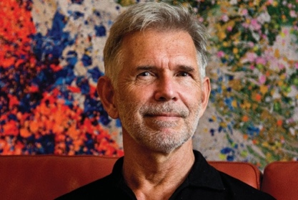  Creative Vision Awardee:  Mike Chearney, artist and advocate  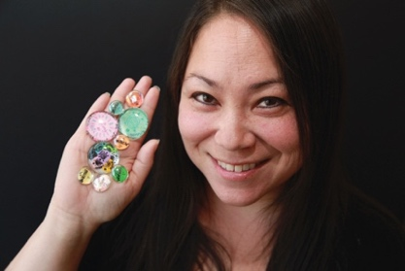  Compassionate Witness Awardee:  Dr. Susan Lee, Windows Leader,  United American Indian Involvement  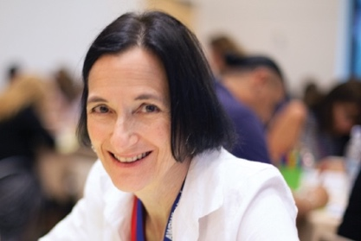  Community Impact Awardee:  Dr. Lin Morel, AWBW Board President  2009-2016 | Venice, CA – August 22, 2017 – On Sunday, October 1, 11am-2pm, local nonprofit A Window Between Worlds (AWBW) will hold its signature heART Awards at Hotel Casa Del Mar in Santa Monica (1910 Ocean Way, 90405). This special brunch honors three incredible community members who embody core values of AWBW’s mission to cultivate and support a network of transformative arts programs empowering individuals and communities impacted by violence and trauma.  Guests will enjoy a delicious champagne brunch, luxury auction items, and the opportunity to bid on artwork created by awardee Mike Chearney in collaboration with AWBW founder Cathy Salser. Titled A Window Between Worlds, this piece consists of 36 individual canvases, painted as one. Two of these pieces — A Window of Breakthroughs and A Window of Faith — are recent ArtSlant Prize winners.  As part of AWBW’s community outreach, AWBW collaborates with contemporary artists who uphold a commitment to transformation through art. Mike Chearney’s artwork does exactly this — channeling healing energy through color, vibration and connection. He will be honored with the Creative Vision Award at this year’s heART Awards.  Dr. Susan Lee will receive the Compassionate Witness Award for her commitment to creating a safe, non-judgmental space for her clients to express themselves. Trained Windows Program Leaders across the country use AWBW trauma-informed art curriculum to open up communication with participants, and Lee’s work at United American Indian Involvement in Los Angeles is a shining example of the difference this approach can make in the community.  Advocating for AWBW and the use of art as a healing tool for nearly 20 years, Dr. Lin Morel will be presented with the Community Impact Award. As AWBW Board President from 2009 to 2016, Morel’s passion and dedication have been instrumental to the organization’s growth and impact.  Tickets for the brunch, and spotlights about the awardees, are available at awbw.org/heartawards. Event sponsors include Kaiser Permanente, NBC/Universal, Foley Family Wines, and Tito’s Handmade Vodka. ###

