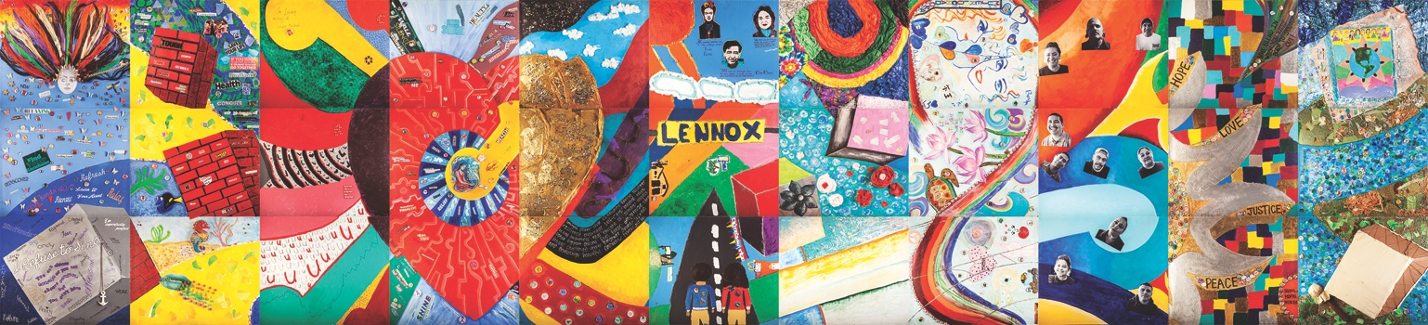
Communities Transforming Through Art
Interactive exhibition featuring collaborative mural project led by Fabian Debora

Los Angeles, CA – May 11, 2017 – “At the Core: Transforming Trauma Together” is the newest community art initiative of nonprofit A Window Between Worlds (AWBW). The central component of this project is a 33-foot mural designed by renowned Los Angeles artist Fabian Debora and completed by people from across Los Angeles County. This mural will be unveiled on Sunday, June 11, 2-5pm at San Fernando Valley Arts and Cultural Center (18312 Oxnard St, Tarzana, CA 91356).

“At the Core” represents our innermost selves, and the hearts of our communities, coming together to use art to transform trauma. It addresses core wounds, core values, core needs, and allows us to pull back the layers to reveal what is at the center of ourselves and our communities.

Debora’s own life includes trauma, domestic violence, gang membership, incarceration and addiction. It also includes art as a grounding tool, self-defining passion, source of confidence and place of belonging. “What was effective in my recovery, my transformation, was to be able to get to the core,” says Debora when describing the project concept. “To embrace it, not be in shame of it, but be able to get to the truth of who I am.”

Debora shared art as this resource for transformation with 11 AWBW partner organizations as they created their own mural panels, including Homeboy Industries where he is Director of Substance Abuse Services and Programming. The other ten participating organizations are Alternatives Behavioral Health, Center for the Pacific-Asian Family, Domestic Violence Center of Santa Clarita Valley, Helping Hands Resource Center, Juntos: Lennox School & Community Wellness, Korean American Family Services, Los Angeles Unified School District, Rainbow Services, Richstone Family Center and United American Indian Involvement.

AWBW has been partnering with human service organizations for 25 years to provide art as a resource for healing. Art is a way for individuals to reclaim their voices and true identities, to find a place of inclusion, and to begin a personal transformation that will ripple out into their families and communities.

The “At the Core” interactive exhibition, supported by LA County Arts Commission and the Department of Cultural Affairs, will be on display through June 24. Exhibition attendees are invited to participate in this project through both creating personal art and contributing to community art pieces. ###

