For Immediate Release  Press Contact:  Emily Anne Evans  Marketing & Communications Manager  310.396.0317 x217  eaevans@awbw.org  Tickets: awbw.org/aia  More photos: awbw.org/media  @AWBWorg • #ArtInTheAfternoon | 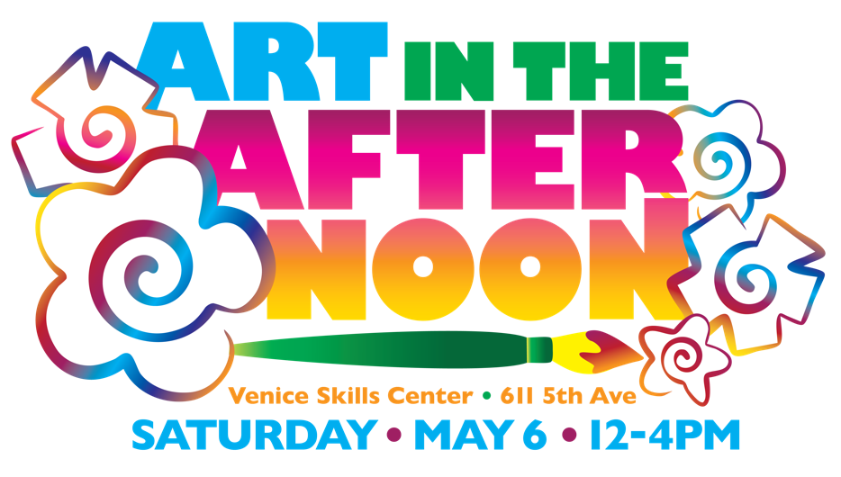

Fun-filled Art Festival for the Whole Family
Hosted by actress and advocate G Hannelius

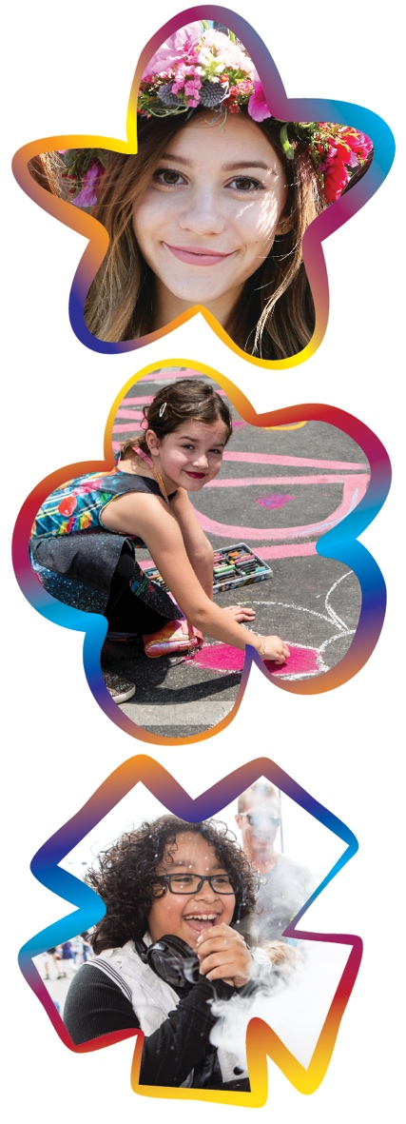 | Venice, CA - April 4, 2016 - On Saturday, May 6 from 12-4pm nonprofit A Window Between Worlds (AWBW) will host Art in the Afternoon, their popular annual art festival, at the Venice Skills Center, 611 5th Avenue. Hosted by G Hannelius, known for her starring role in "Dog with a Blog,” this event brings out multiple teen celebrities, as well as people from across Los Angeles and Southern California in support of AWBW’s healing art programs.  Tickets are available at awbw.org/aia. Kids (12 and under) are $15, Teens (13-17) $25 and Adults $60. You can also sponsor an AWBW program participant’s attendance through the website.  Attended by over 700 people in 2016, admission includes free food from In-N-Out® Burger (12-2pm), Panda Express, Fresh Brothers and Hubert’s Lemonade. Tickets also include art projects, face painting, chalk art and Hoop it Up Hula Hooping. Color Me Mine and Jeni’s Splendid Ice Creams will also be there, along with multiple carnival games (with prizes), a bouncy slide for the kids and live and silent auctions for the adults.  G Hannelius is thrilled to be involved for the seventh year in a row: “Art has always been a really special part of my life, so I love that this event brings the whole community together to create,” she says.  A Window Between Worlds is a nonprofit organization based in Venice with arts programs for survivors of violence and trauma throughout the country. Since 1991, AWBW’s art workshops have offered over 200,000 people the opportunity to express their thoughts and feelings, without fear of judgment, by creating art in a safe environment.  Proceeds for Art in the Afternoon will directly benefit AWBW’s network of transformative arts programs through funding scholarships, art supplies, trainings, curriculum development and the launching of new programs.  Additional community supporters of Art in the Afternoon include NBC/Universal, Dogeared, Google LA, The Art Institute of CA – Hollywood, ivivva by Lululemon and Hogan Lovells. ###

