FOR IMMEDIATE RELEASE  Press Contact:  Emily Anne Evans  A Window Between Worlds  Marketing and Communications Manager  310.396.0317 x217  eaevans@awbw.org  awbw.org/dvam  @AWBWorg | 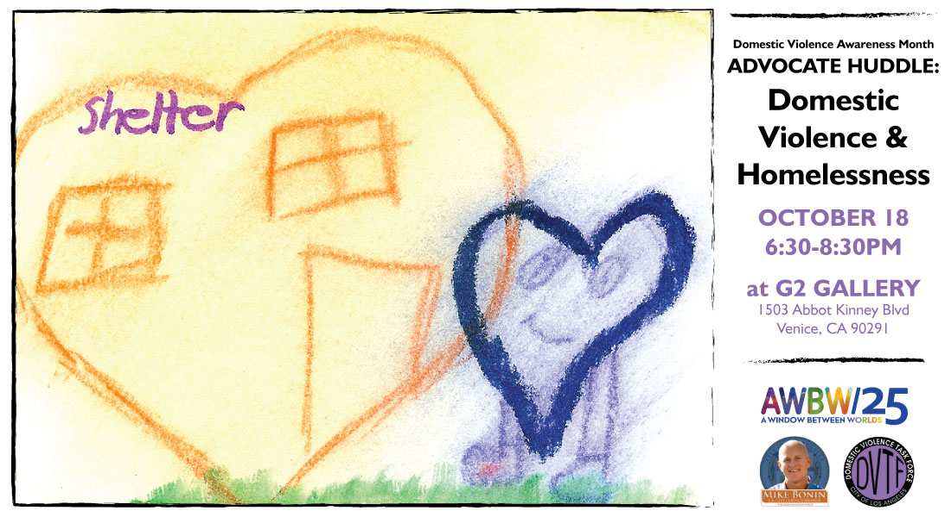

The Impact of Domestic Violence on Homelessness
LA City DV Task Force, City Council District 11 and AWBW partner to raise awareness

Venice, CA – October 4, 2016 – In observance of 2016 Domestic Violence Awareness Month, people from across Los Angeles will gather on October 18, 6:30-8:30pm at G2 Gallery (1503 Abbot Kinney Blvd, Venice, California 90291) for a special Advocate Huddle about domestic violence and homelessness. The evening will include speakers, discussion, refreshments and a collaborative art project. As always, A Window Between Worlds (AWBW) Advocate Huddles are free and open to the public; RSVP at awbw.org/dvam.

The event will feature a variety of speakers knowledgeable about the overlap of these issues and how we can work toward solutions. Carol Tantau of the City of Los Angeles Domestic Violence Task Force and Sojourn, a project of OPCC, will speak, along with Jessica Reed from Los Angeles Homeless Services Authority (LAHSA). Representatives from the DV Task Force, City Council District 11, Venice-based arts nonprofit AWBW, and other local agencies and advocates will also be present for community discussion.

The mission of the City of Los Angeles Domestic Violence Task Force is to assist the city with the development and coordination of domestic violence programs, and to make recommendations to the City Council regarding policies, priorities, funding, legislation, and any other pertinent matters related to domestic violence. Additional DV Awareness events are being held throughout the city in October.

Councilmember Mike Bonin of the 11th District serves on the city’s Homelessness and Poverty Committee and is an avid supporter of Proposition HHH. He is also the DV Task Force’s Special Liaison to the City Council and premier supporter for all DVTF efforts. "We must do everything we can to end homelessness throughout Los Angeles by providing those who need it and want it with housing and appropriate services,” he says. Nationwide over 70% of unmet service requests for survivors of domestic violence are for housing.¹

A Window Between Worlds, the host of the Advocate Huddle, partners with agencies throughout Los Angeles and the country to use art as a tool for healing and empowerment with those impacted by violence and trauma. The work of AWBW is rooted in reaching domestic violence survivors, and has recently expanded to address the multiple ways trauma and violence occur and intersect in people’s lives, including homelessness.

In Los Angeles, domestic violence is a major contributing factor to homelessness for nearly 20% of unsheltered individuals.² Nationwide 80% of homeless mothers with children have experienced domestic violence at some point in their lifetime.³ The cycle of violence and homelessness needs to stop, and we can all contribute to finding solutions. Attend this event October 18 to learn more about how you can help make a difference.

1: National Network to End Domestic Violence, 2015 Domestic Violence Counts (nnedv.org)
2: Los Angeles Homeless Service Authority, 2016 Greater Los Angeles Homeless Count (lahsa.org)
3: National Center for Children in Poverty, Homeless Children and Youth: Causes and Consequences (nccp.org)

